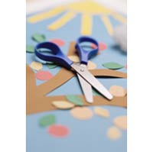
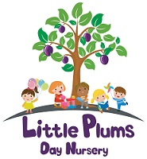
It's fun to play at home
Oak Tree Children’s Centre
Cutting & sticking!

What you could use:
Child scissors (could tear and scunch instead of cutting)
Glue
Magazines
Food boxes
Food labels
Paper
Newspapers
Leaves
Grass
Petals
Twigs
Pasta
Rice
Cellotape
Masking tape
Explore the items you’ve collected.
Use words to describe.
Let child choose what they want to cut & stick.
Find other things to use from inside or outside your home.

Lets talk:
Sticky
Smooth
Cut
Tear
Pull
Rough
Smooth

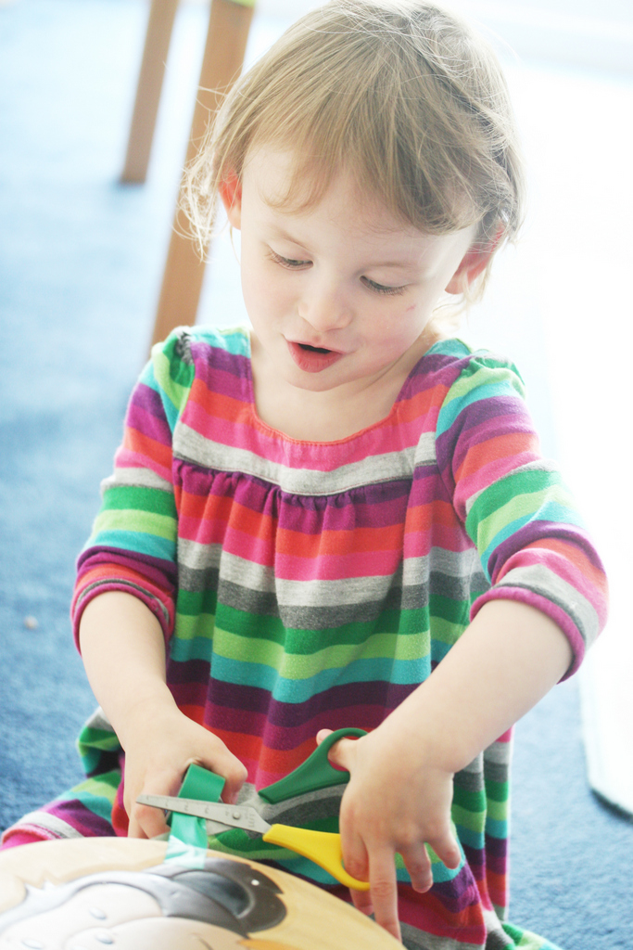
This will help your child to explore and experiment with different materials using their imagination.

